**Industrial Training Project Report** on

**“ iGenie (Stock Market Portal)” For**

**Hushtell**

Submitted By

**15640 Saurabh Vijay Jadhav**

Under The Guidance of

**Ms. Rita Gupta**

**MSC(Comp. Science) - II Semester-IV**

**MES’ ABASAHEB GARWARE COLLEGE**

**KARVE ROAD, PUNE-04**

**Affiliated to**

**Savitribai Phule Pune University**

Year 2022-2023

To,

Saurabh Jadhav

Date- 19/05/2023

**To Whomsoever It May Concern**

This is to certify that **Saurabh Jadhav**, student of **Msc(Computer Science)** at

**Abasaheb Garware College** has completed an internship as a Software Development

Intern from **9 Jan 2023** and he is still continuing her internship here at **HushTell Technologies LLC.**

Over the internship duration, he worked on the "**iGenie**" project developing backend API’s using **FastAPI**, **Python, Swagger UI, Postman & MongoDB**.

He was found to be sincere and hardworking during the tenure and completed all internship related tasks successfully.

For HushTell Technologies LLC



**Sanjay Kataria** Director.

**ACKNOWLEDGEMENT**

I would like to express my sincere gratitude and appreciation to

everyone who has supported me throughout my internship project..

First and foremost, I am deeply grateful to Mr. Sanjay Kataria of Hushtell, for providing me with this valuable opportunity and guiding me through the entire project. Their feedback and guidance were essential to my growth and learning during this internship.

I would also like to express my sincere thanks to Prof. Chitra Nagarkar (HOD, Comp. Sci. Dept) and my project Guide Ms. Rita Gupta and all the teachers of my college who all have given me excellent technical and moral support throughout my post-graduation period

Thank you all for your invaluable support and contributions to this

project. Your help and guidance were instrumental in helping me to achieve my goals and succeed in this internship program.

.

**INDEX**

|  |  |  |
| --- | --- | --- |
| **Sr. No** | **Content** | **Page No.** |
|  | **Company Certificate** | 2 |
|  | **Acknowledgement** | 3 |
|  |  |
| **1** | **Introduction** | 5 - 9 |
|  |
| 1.1 | Company Profile | 5 |
| 1.2 | Project Profile | 6 |
| 1.3 | Existing system | 7 |
| 1.4 | Proposed system | 8 |
| 1.5 | Scope of the work | 9 |
| **2** | **System Requirements Specification** | 10 |
| 2.1 | Hardware & Software requirements | 10 |
| **3** | **Feasibility Study** | 11 - 12 |
| **4** | **System Design/UML Diagrams** | 13 - 18 |
|  |  |
| 4.1 | ER diagram | 13 |
| 4.2 | Class Diagram | 13 |
| 4.3 | Use Case Diagram | 14 |
| 4.4 | Activity Diagram | 15 |
| 4.5 | Sequence Diagram | 16 |
| 4.6 | Testing | 17 |
| **5** | **Input/output Screen Layout** | 19 - 24 |
|  |
| **6** | **Future Enhancement** | 25 |
|  |
| **7** | **Conclusion** | 26 |
|  |
| **8** | **Bibliography** | 27 |
|  |

1. **INTRODUCTION**

**1.1 COMPANY PROFILE :**

**Company Name:**

HUSHTELL TECHNOLOGIES LTD

**About :**

At HushTell, we are passionate about technology. Our clients come to us seeking customized, skilfully crafted business applications. Our longevity is due to the skill and efficiency of our team of senior software engineers, project managers, and devops staff.

We specialize in enterprise business applications that optimize business processes and handle large amounts of data and traffic. We only produce modern software with a focus on quality, usability, and scalability.

Our mission is to help enterprises accelerate adoption of new technologies, untangle complex issues that always emerge during digital evolution, and orchestrate ongoing innovation. Whether it is a consumer-oriented app or a transformative enterprise-class solution, the company leads the process from ideation and concept to delivery, and provides ongoing support.

**The core values that guide us**

* **Dedication to client success**

We bring a spirit of empathy and a willingness to do what it takes. We don’t fail to deliver.

* **Drive to the "why"**

Always favouring simplicity, we remain solutions-oriented and dispassionately pragmatic.

* **Pursue excellence**

The right people do the right work. At HushTell, we embrace expertise and cultivate excellence.

* **Act with integrity**

We act like owners. We say what we mean and we do the right thing.

**1.2. PROJECT PROFILE :**

● **Introduction** 

In today's fast-paced world, stock markets play a vital role in the global economy. To keep up with the ever-changing trends and updates in the stock market, having a reliable and user-friendly stock market portal is essential.

In this project, we aim to create a comprehensive stock market portal that provides users with the latest news, analysis, and insights about the stock market. Our portal will feature real-time stock quotes, interactive charts, and financial data to help users make informed decisions about their investments.

We also plan to include a customizable watchlist feature, where users can track their favourite stocks.

Our goal is to provide a user-friendly platform that caters to both novice and seasoned investors. We believe that our stock market portal will be a valuable resource for anyone interested in the stock market, whether they are a beginner or a seasoned investor.

**1.3 EXISTING SYSTEM:**

There are numerous stock market already available to users. While these portals offer a range of useful features, there is always room for improvement. These portals offer a range of features, including real-time stock quotes, interactive charts, financial news, and analysis.

But on some sites there is a huge amount data present in raw form without proper processing, that it may cause the users to get confused and not make proper decisions. While in some sites information about stocks is relatively less which also causes users to not make proper decisions.

Our goal is to create a more user-friendly and comprehensive platform that provides users with even more tools and resources to make informed decisions about their investments.

**1.4 PROPOSED SYSTEM:**

Our proposed system for the stock market portal aims to provide users with a more comprehensive and user-friendly platform than the existing systems.

Here are some of the key features of our proposed system:

1. Real-time stock quotes: We will provide users with real-time stock quotes for stocks from major stock exchanges around the world.

1. Interactive charts: Our platform will feature interactive charts that allow users to visualize stock price trends and compare different stocks.

1. Customizable watchlist: Our platform will feature a customizable watchlist that allows users to track their favorite stocks and receive alerts when the price of a stock reaches a certain level.

1. User-friendly interface: We will design our platform with a user-friendly interface that is easy to navigate, even for novice investors.

Overall, our proposed system aims to provide a comprehensive platform that caters to both novice and seasoned investors, providing them with the tools and resources they need to make informed decisions about their investments.

# 1.5 SCOPE OF THE WORK :

This application is developed for easing the decision making of users

* User can create their own account which is protected by password and OTP. Access token is generated upon successful validation, without which access to protected pages is restricted and hence securing one’s private information. 
* User can create watchlists according for different type of tocks and edit, remove or rename them easily. 
* User can search stocks and add them to preferred watchlists or remove them from watchlists. 
* User can see specific stock information in an easy-to-understand way. Real time stock information and playback of stock information can also be seen.

**2. SYSTEM REQUIREMENTS SPECIFICATION**

## 2.1 HARDWARE & SOFTWARE REQUIREMENTS :

**Hardware Requirements**

* Processor: Pentium 2,500 MHz (or above).

* RAM: 2GB (or Above)

**Software Requirements**

|  |  |
| --- | --- |
| Operating System | Linux/ Windows |
| Frontend | React |
| Backend | FAST API Python |
| Database | MongoDB |
| Design | JSX |
| Deployment | Internet Browser |

**3. FEASIBILITY STUDY**

A feasibility study is a high-level capsule version of the entire System analysis and Design Process. The study begins by classifying the problem definition. Feasibility is to determine if it’s worth doing. Once an acceptance problem definition has been generated, the analyst develops a logical model of the system. A search for alternatives is analyzed carefully. There are 3 parts in feasibility study. There are three terms technical, economic and operational feasibility.

1. **Operational Feasibility:**

Operational feasibility is a measure of how well a proposed system solves the problems, and takes advantage of the opportunities identified during scope definition and how it satisfies the requirements identified in the requirements analysis phase of system development. This product is operationally feasible as it is designed specifically for the corresponding business. This provides consistent and integrated data management. It also provides information on each subsystem of the business process. It fulfills the requirements of the system as identified during development. The system is accurate and easy to use.

1. **Technical Feasibility:**

To deploy the application, the only technical aspects needed are mentioned below:

Operating Environment Win 10

Platform Visual Studio

Database MongoDB

1. **Economical Feasibility:**

The project is economically feasible as the only cost involved is having a computer with the minimum requirements mentioned earlier. For the users to access the application, the only cost involved will be in getting access to the Internet.

1. **SYSTEM DESIGN / UML DIAGRAMS**

* 1. **Entity Relationship Diagram :**

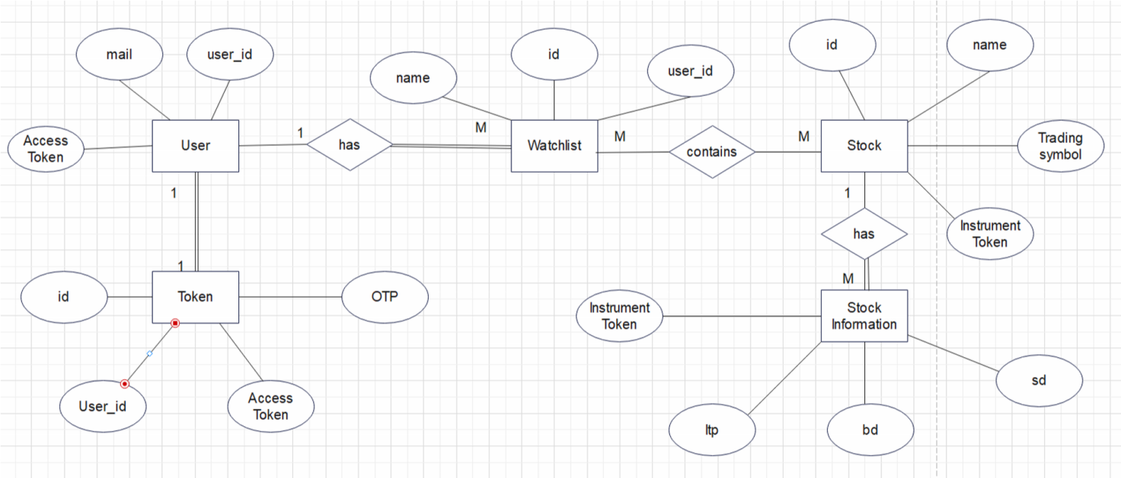

* 1. **Class Diagram :**

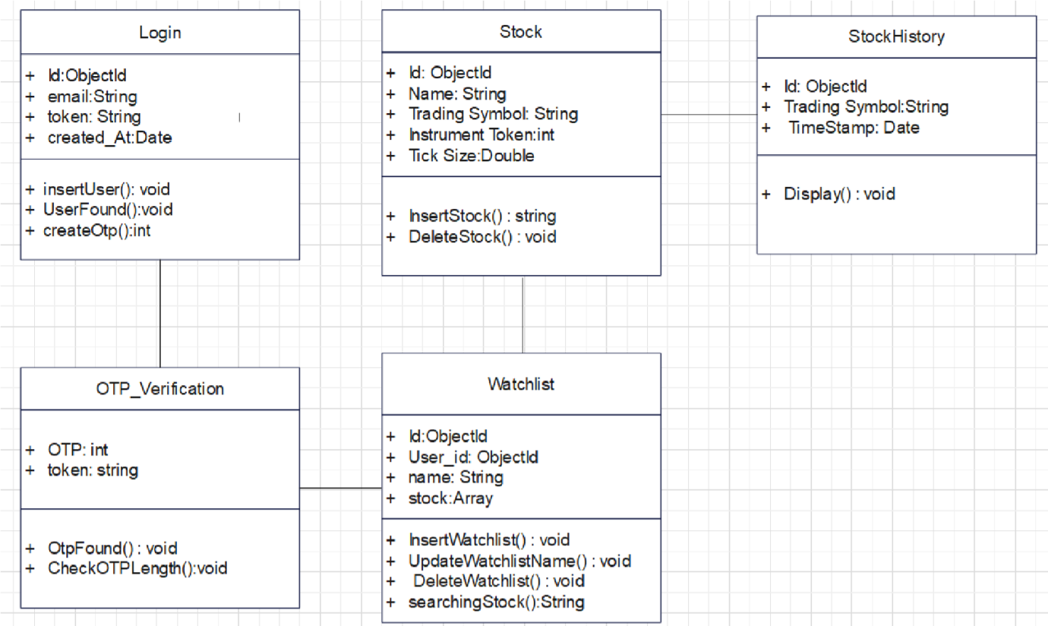

* 1. **Use Case Diagram :**

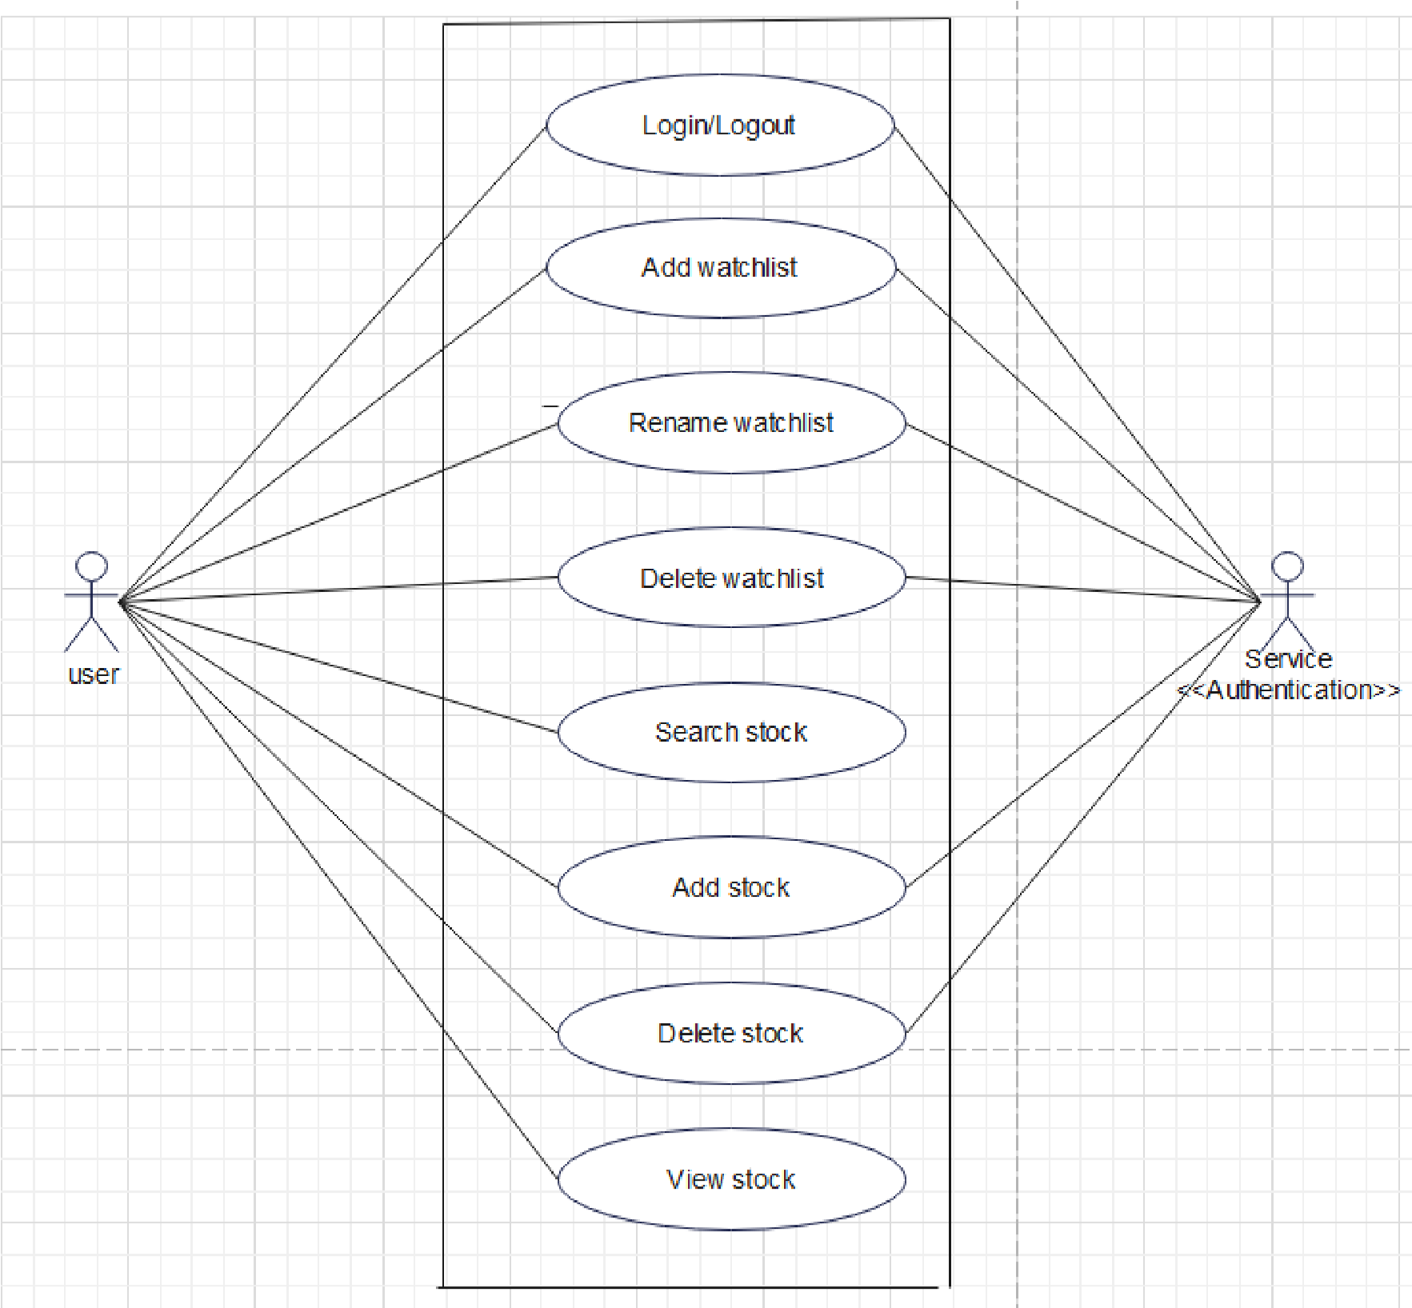

* 1. **Activity Diagram**

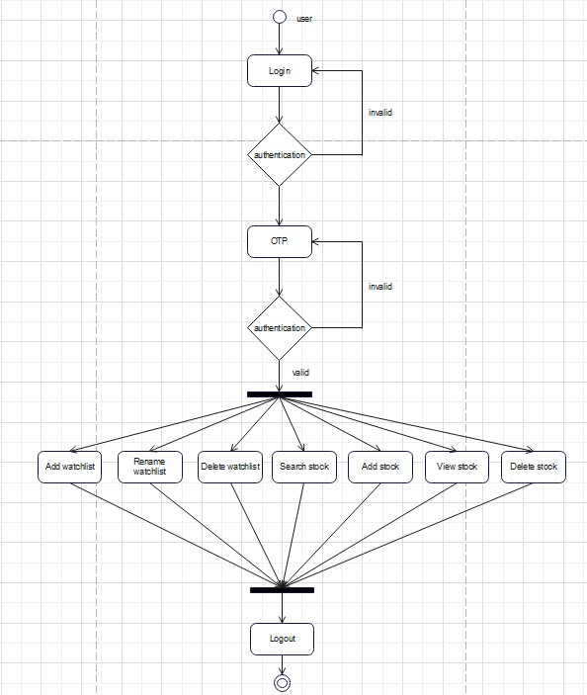

* 1. **Sequence Diagram :**

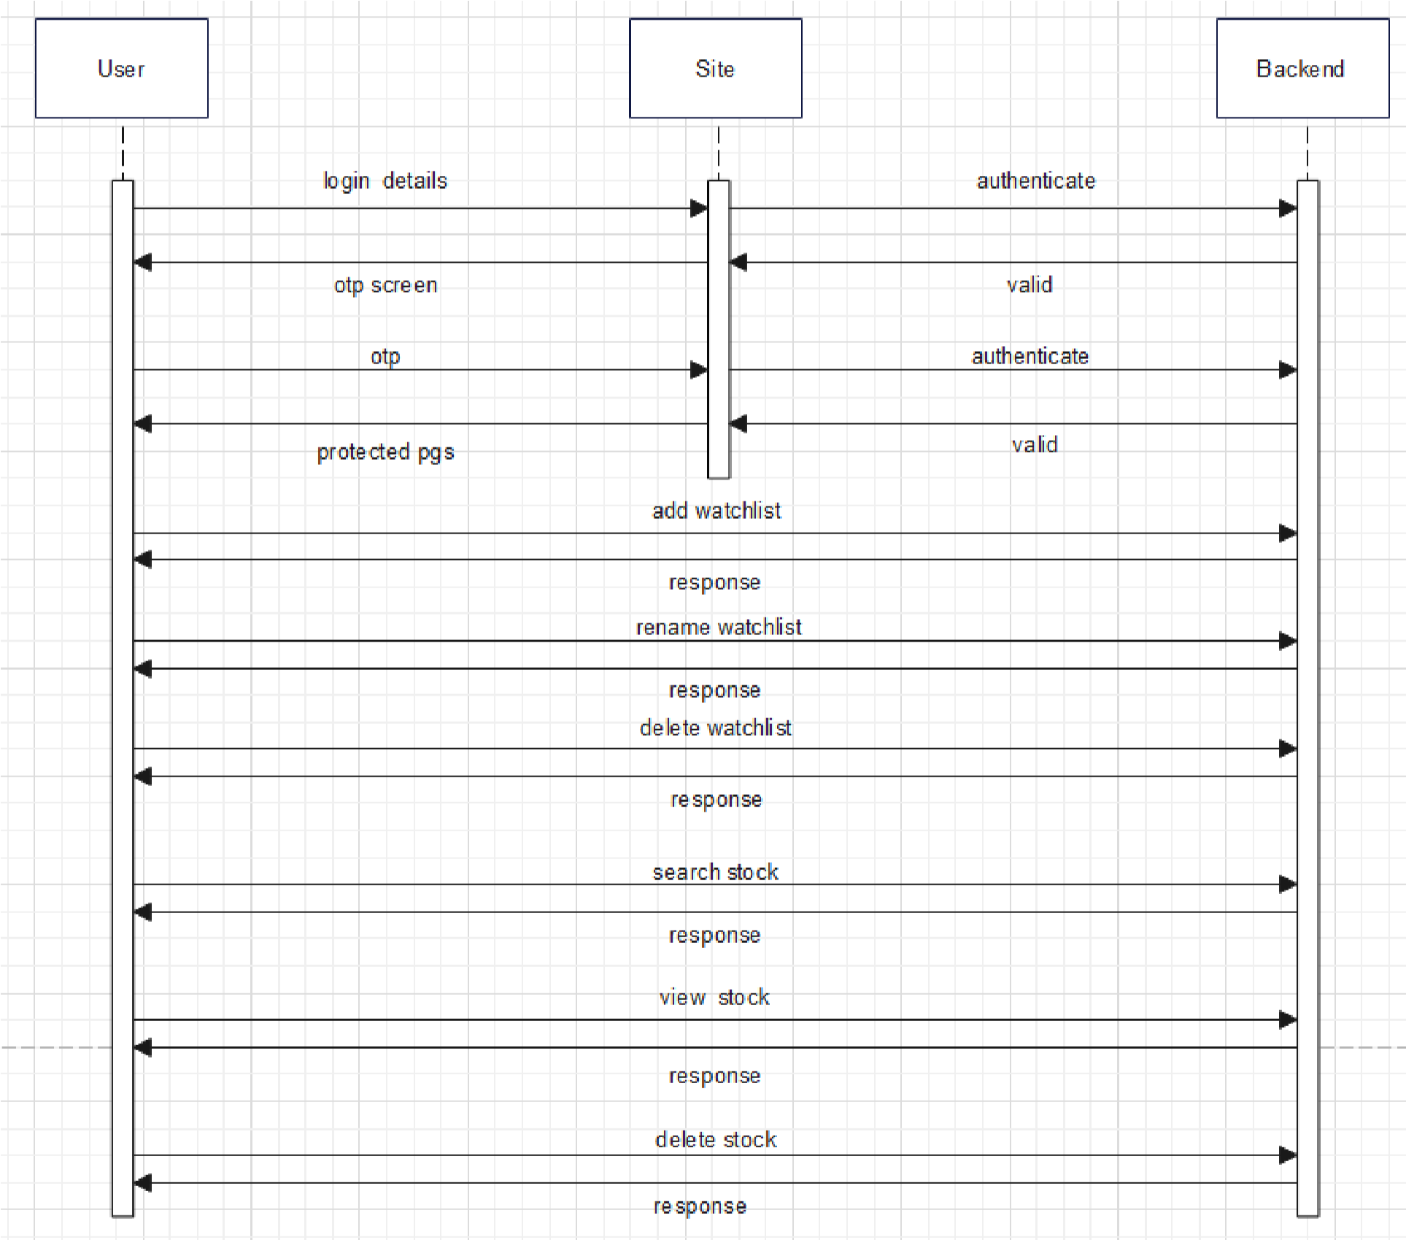

* 1. **Testing :**

**Login Form**

|  |  |  |  |  |  |
| --- | --- | --- | --- | --- | --- |
| **No** | **Test Step** | **Test Data** | **Expected Result** | **Actual Result** | **Status** |
| 1 | User email is not enter and click on login button | Email:” “ | User Should be Login | Show error  Message “Email is required“ | Pass |
| 2 | Enter Invalid Email | Email:”xyz” | Enter a Email | Show error message ”Email Invalid” | Pass |
| 3 | Enter valid Email | Email:  ”sj2932000@gmail.com” | Login Successfully | Login Successfully | Pass |

**OTP Verification**

|  |  |  |  |  |  |
| --- | --- | --- | --- | --- | --- |
| **No** | **Test Step** | **Test Data** | **Expected Result** | **Actual Result** | **Status** |
| 1 | OTP is not enter and click on login button | {  “OTP”:0,  “token”:”jhj6hjk9kii”  } | Enter OTP | Show error  Message “OTP is required“ | Pass |
| 2 | Token is not enter and click on login button | {  “OTP”:9898,  “token”:””  } | Enter Token | Show error message ”Token is required” | Pass |
| 3 | OPT length is not valid | {  “OTP”:98988,  “token”:”ji7gyu6jj8kjj”  } | Enter Valid OTP | Show error message”Invalid OTP Length” | Pass |
| 4 | Enter invalid OTP | {  “OTP”:9899,  “token”:”ji7gyu6jj8kjj”  } | Enter Correct OTP | Show error message”InCorrect OTP” | Pass |
| 5 | Enter valid OTP and Token | {  “OTP”:9899,  “token”:”ji7gyu6jj8kjj”  } | OTP Verified | OTP verified | Pass |

**SearchStockSymbol**

|  |  |  |  |  |  |
| --- | --- | --- | --- | --- | --- |
| **No** | **Test Step** | **Test Data** | **Expected Result** | **Actual Result** | **Status** |
| 1 | Search Valid Stock | {  “symbol”:”idea”  } | Display stock | Display stock | Pass |
| 2 | Symbol is not enter | {  “symbol”:””  } | Enter symbol | Show error message ”Trading symbol name is empty” | Pass |
| 3 | Symbol is not in string format | {  “symbol”:123  } | Enter Valid symbol | Show error message”symbol is not in string format” | Pass |
| 4 | Symbol not found | {  “Symbol”:”jij”  } | Invalid Stock | Show error message”Symbol not found” | Pass |

**WatchlistInsert**

|  |  |  |  |  |  |
| --- | --- | --- | --- | --- | --- |
| **No** | **Test Step** | **Test Data** | **Expected Result** | **Actual Result** | **Status** |
| 1 | Insert Watchlist | {  name:”sss “  } | Display Watchlist | Display Watchlist | Pass |
| 2 | Empty WatchlistName | {  name:” ”  } | Enter a Watchlist Name | Show error message ” WatchlistName is empty” | Pass |
| 3 | Watchlist name is already exit | {  Name”xyz”  } | Enter another name | Show error message”Watchlist name is already exit” | Pass |

**UpdateWatchlistName**

|  |  |  |  |  |  |
| --- | --- | --- | --- | --- | --- |
| **No** | **Test Step** | **Test Data** | **Expected Result** | **Actual Result** | **Status** |
| 1 | WatchlistName  updated | {  “name”:”watchlist1”  “watchlist_id”:66  } | Successfully Updated | Watchlist Successfully Updated | Pass |
| 2 | Empty WatchlistName | {  name:” ”,  “watchlist_id”:66  } | Enter a Watchlist Name | Show error message ” WatchlistName is empty” | Pass |
| 3 | Watchlist name is already exit | {  Name:”xyz”,  “watchlist_id”:66  } | Enter another name | Show error message”Watchlist name is already exit” | Pass |
| 4 | Watchlist Not Found | {  “name”:”kkk”  “watchlist_id”:66  } | Enter Correct Watchlist id | Show error message”Watchlist not found” | Pass |

InsertStock

|  |  |  |  |  |  |
| --- | --- | --- | --- | --- | --- |
| **No** | **Test Step** | **Test Data** | **Expected Result** | **Actual Result** | **Status** |
| 1 | Inserted  Stock | {  “Symbol”:”idea”,  “token”:987678  } | Display stock in watchlist | Display stock in watchlist | Pass |
| 2 | Empty Symbol | {  “Symbol”:””,  “token”:987678  } | Enter Symbol | Show error message ”Symbol is empty” | Pass |
| 3 | Empty Tolen | {  “Symbol”:”idea”,  “token”:0  } | Enter Token | Show error message”Token is empty” | Pass |
| 4 | Stock is already exit | {  “Symbol”:”idea”,  “token”:987678  } | Enter another name | Show error message”Watchlist name is already exit” | Pass |

**DeleteStock**

|  |  |  |  |  |  |
| --- | --- | --- | --- | --- | --- |
| **No** | **Test Step** | **Test Data** | **Expected Result** | **Actual Result** | **Status** |
| 1 | Stock deleted from watchlist | {  “watchlist_id”:77,  “token”:987678  } | Stock deleted from watchlist successfully | Stock deleted from watchlist successfully | Pass |
| 2 | Invalid token | {  “watchlist_id”:77,  “token”:9876788  } | Invalid token | Show error message ”Invalid token” | Pass |

**DeleteWatchlist**

|  |  |  |  |  |  |
| --- | --- | --- | --- | --- | --- |
| **No** | **Test Step** | **Test Data** | **Expected Result** | **Actual Result** | **Status** |
| 1 | Watchlist delete | {  “watchlist_id”:8  } | Wachlist deleted successfully | Wachlist deleted successfully | Pass |
| 2 | Invalid watchlist | {  “watchlist_id”:87  } | Enter valid watchlist_id | Show error message ”Watchlist_id invalid” | Pass |

**5. INPUT/OUTPUT SCREEN LAYOUT**

**Few screens from stock market portal:**

Login screen :

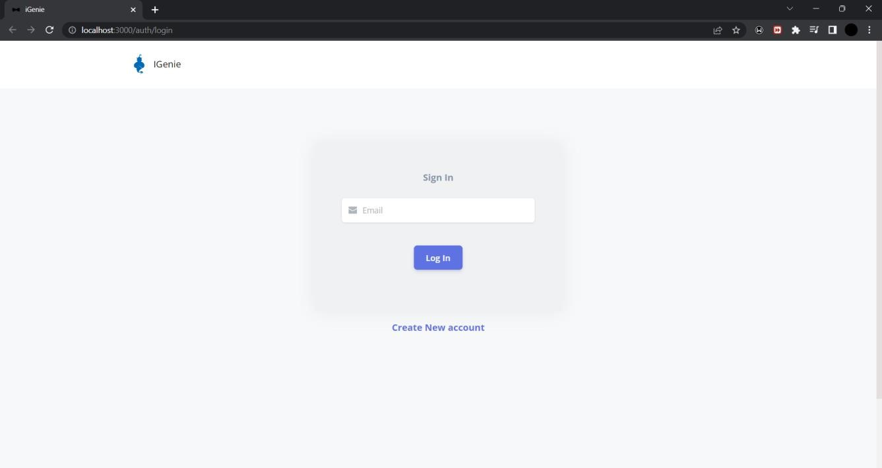

OTP screen:

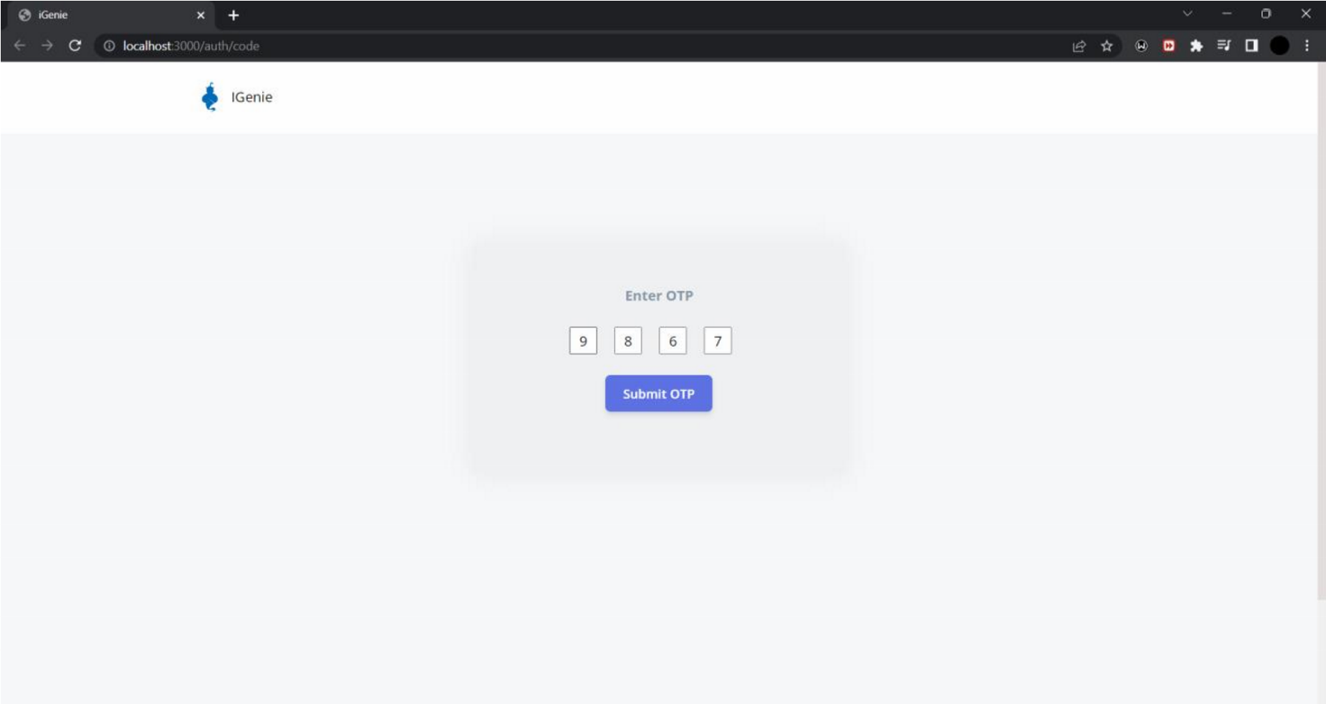

Main screen:

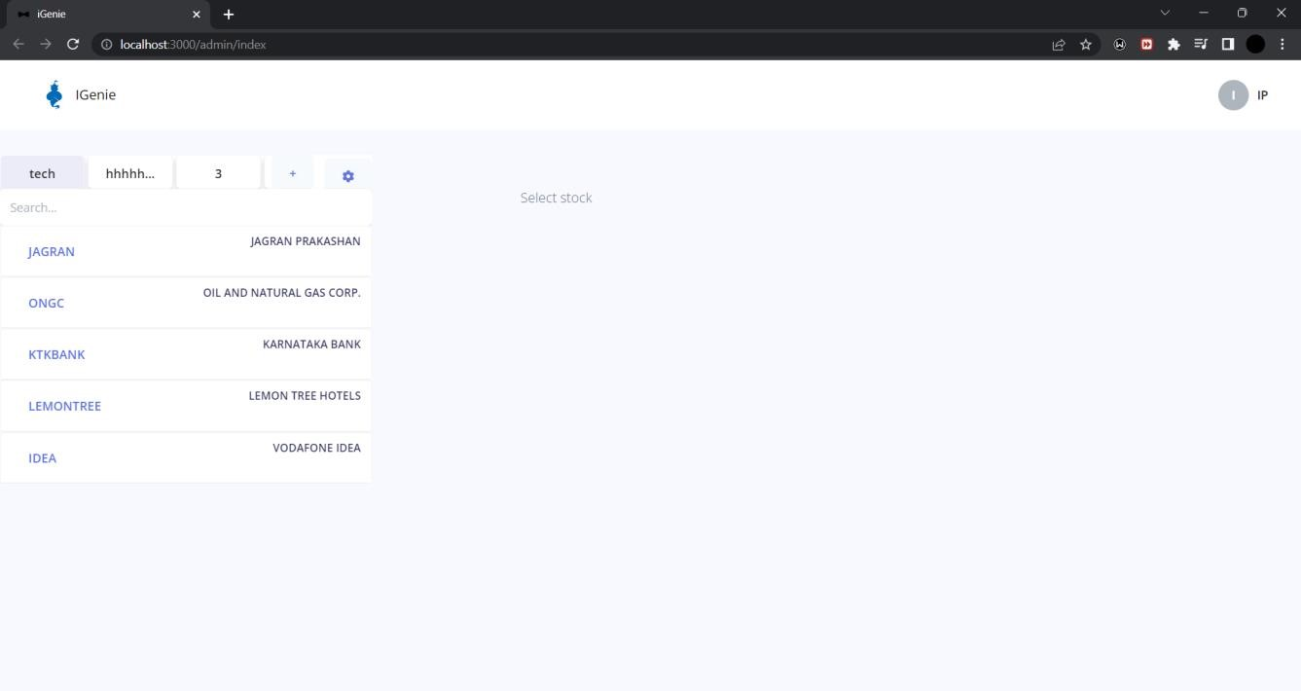

Watchlists:

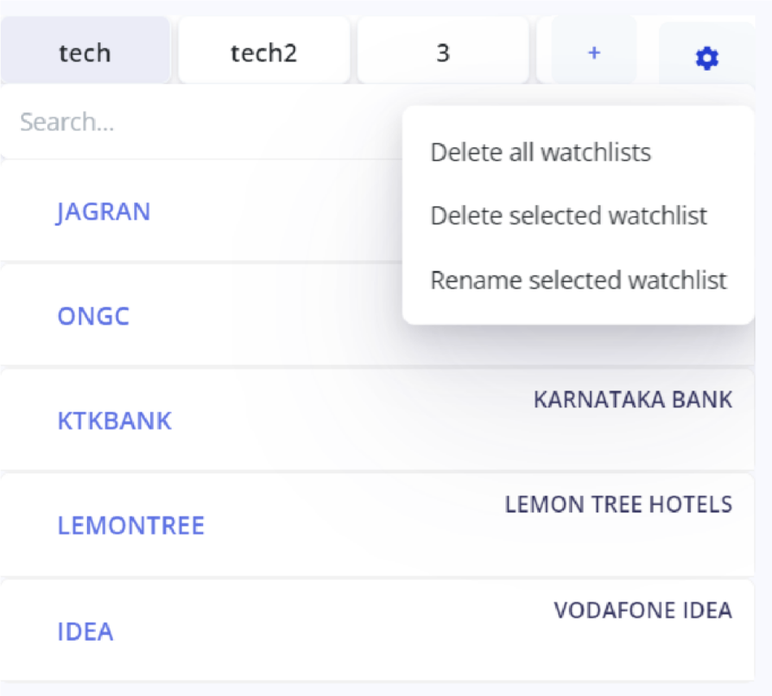

Naming/ re-naming watchlist:

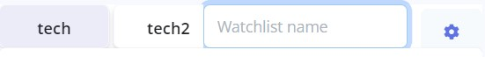

Searching stock:

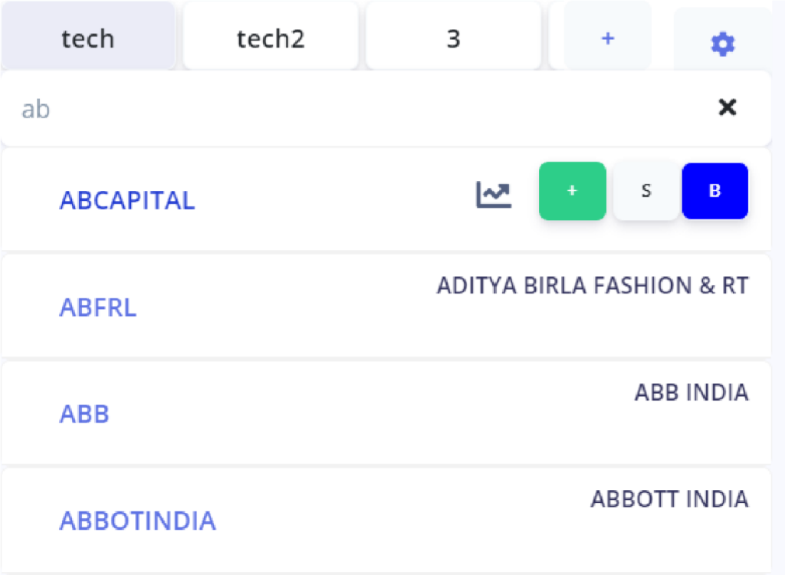

Stocks :

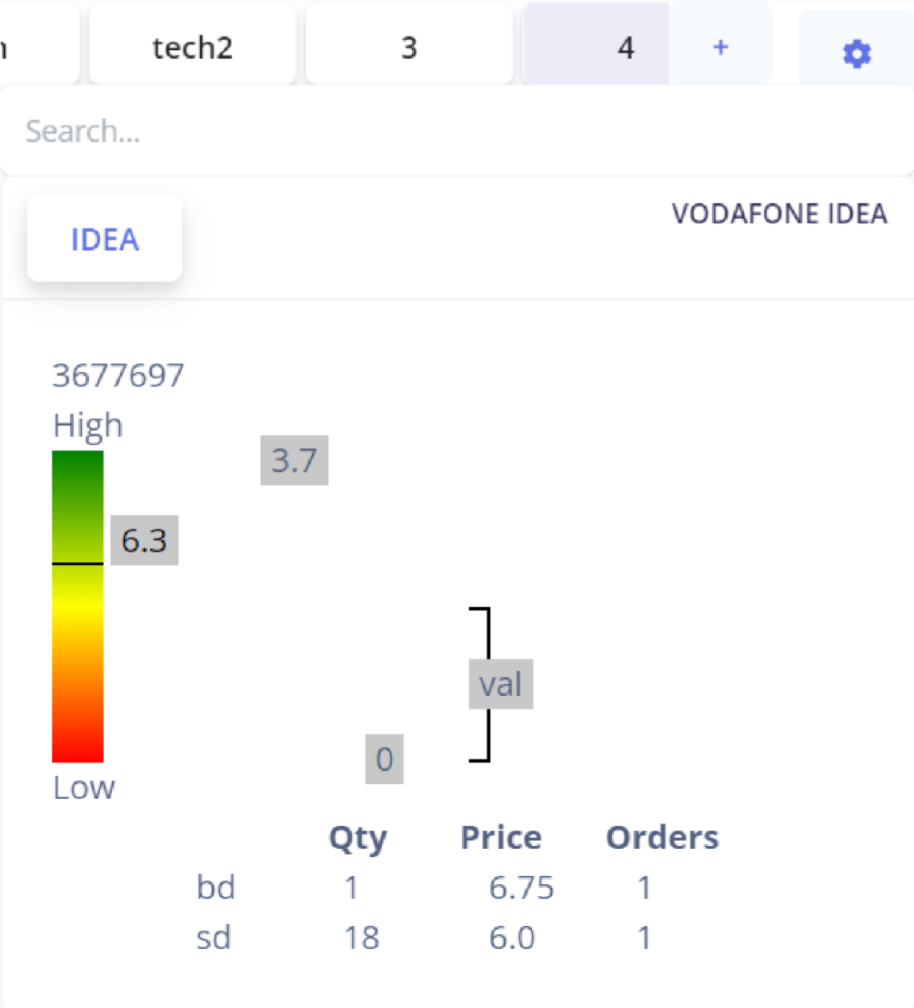

Stock information:

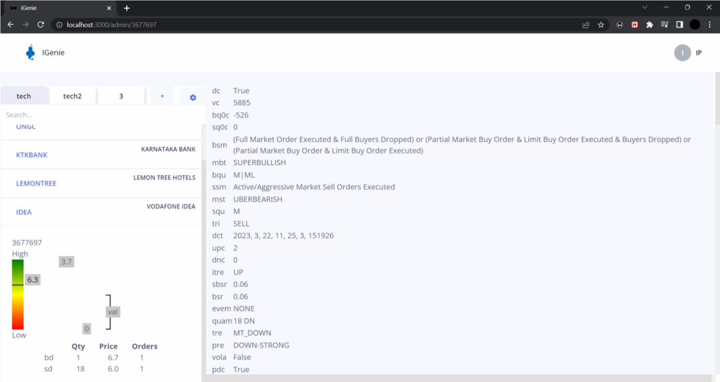

Company site:

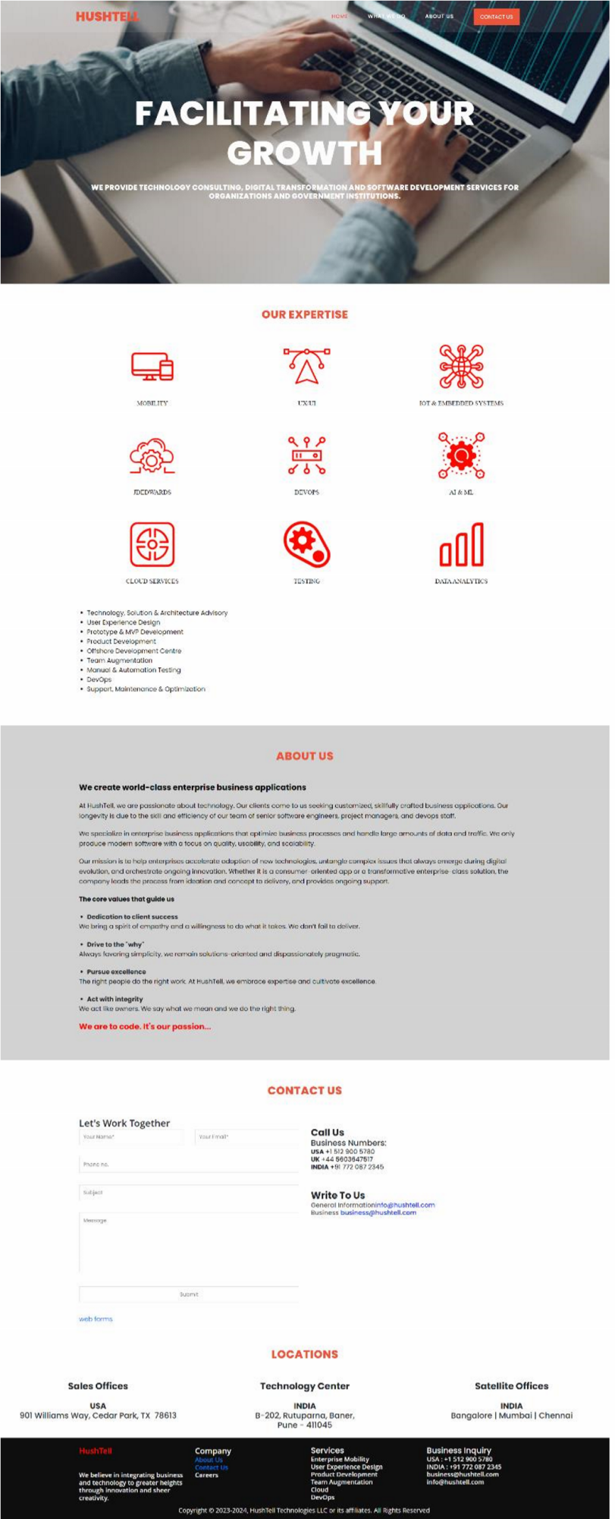

**Screens from training:** News site:

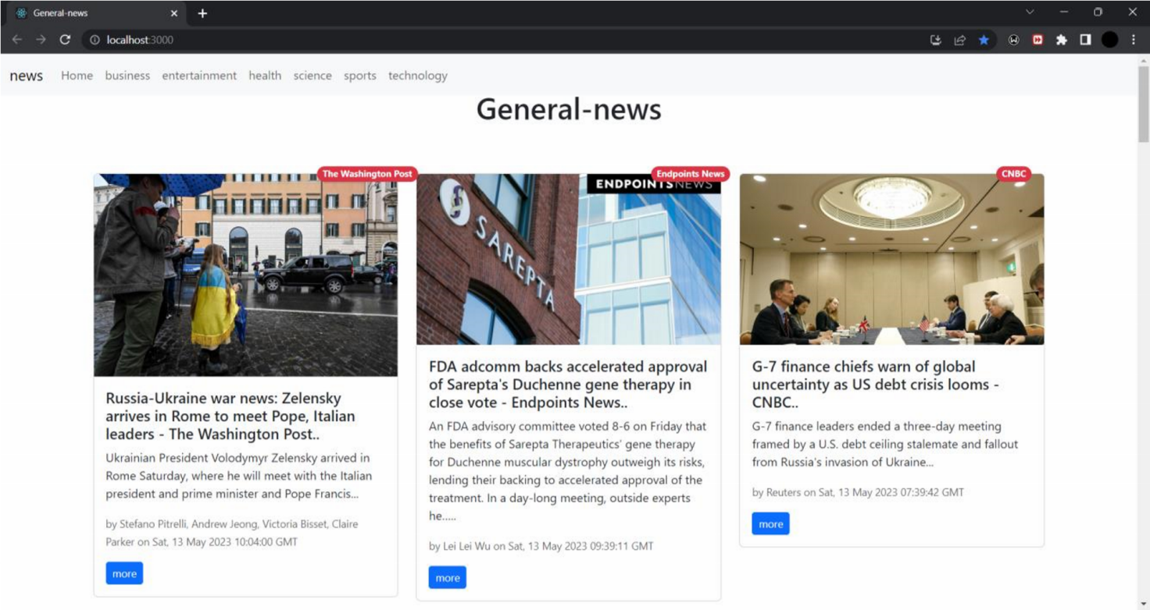

Text editor site:

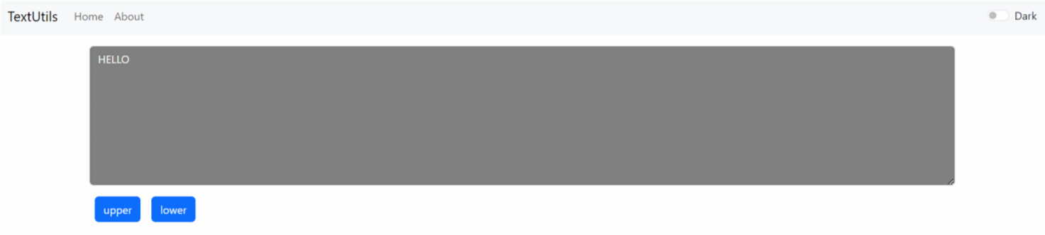

Personal notes site:

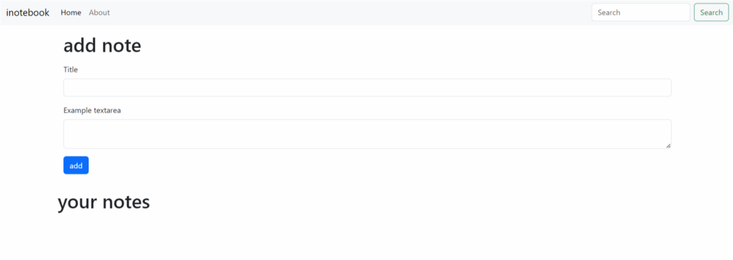

**6. FUTURE ENHANCEMENT**

1. Adding feature of buying stock
2. Adding feature of selling stock

3.Adding more interactive graphs plotting various stock values

4.Integrating it with real-time stock data

**7. CONCLUSION**

* This stock market portal makes it easier for users to make productive decisions by making the most of the stock information.
* User account is secure and users can easily look up their preferred stocks and edit them.
* Watchlists can be named which is not available in other sites leading to ease of user.

**8. BIBLIOGRAPHY**

**Sites**

* <https://getbootstrap.com/> 
* <https://react.dev/> 
* https://legacy.reactjs.org/  
* <https://github.com/creativetimofficial/argon-dashboard-react> 
* <https://zerodha.com/> 
* [https://youtube.com ](https://youtube.com/)
* <https://fastapi.tiangolo.com>
* <https://www.python.org>

 